# A Report on Mini Project

**“Snowflake for Healthcare Analytics - Leveraging Clinical and Patient Data for Insights and Decision Making”**

***Submitted to***

##### GURU NANAK INSTITUTIONS TECHNICAL CAMPUS (Autonomous)

*In partial fulfilment of the requirement for the award of the degree of*

### BACHELOR OF TECHNOLOGY IN

**COMPUTER SCIENCE & ENGINEERING (INTERNET OF THINGS)**

***Submitted by***

#### AMOGH PITTI : (21WJ1A6905)

**A. SAMEEKSHA REDDY : (21WJ1A6901) KONDAPARTHY THARUN : (21WJ1A6935)**

Under the guidance of

### Mr. A. KRISHNA

**Assistant Professor, Department of CSE - IOT, GNITC**



**Department Of Computer Science Engineering – Internet of Things**

**GURU NANAK INSTITUTIONS TECHNICAL CAMPUS (AUTONOMOUS)**

School of Engineering & Technology,

(Approved by AICTE, New Delhi, permanently affiliated to JNTUH, An Autonomous NBA, NACC A+ Accredited Institution) Ibrahimpatnam, Hyderabad - 501506, Telangana, 2024-2025



**Department of Computer Science & Engineering – Internet of Things**

**CERTIFICATE**

This is to certify that this minor project entitled **“SNOWFLAKE FOR HEALTHCARE ANALYTICS – LEVERAGING CLINICAL AND PATIENT DATA FOR INSIGHTS**

**AND DECISION MAKING”** being submitted by Amogh Pitti (21WJ1A6905), A.Sameeksha Reddy (21WJ1A6901) and Kondaparthy Tharun (21WJ1A6905) in partial fulfilment for the award of the Degree of **Bachelor of Technology** in **Computer Science & Engineering – Internet of Things** to **Guru Nanak Institution Technical Campus, Hyderabad** during the academic year 2024-2025, is a record of Bonafide work carried out under our guidance and supervision at **Guru Nanak Institutions Technical Campus (Autonomous).**

|  |  |  |
| --- | --- | --- |
| **Mr. A. Krishna** | **Mrs. Megha Dabas** | **Dr. S. Madhu** |
| **INTERNAL GUIDE** | **PROJECT COORDINATOR** | **HOD** |

### EXTERNAL EXAMINER





PROJECT COMPLETION CERTIFICATE

This is to certify that the following students of final year B. Tech, Department of **Computer Science and Engineering (Internet of Things)** - Guru Nanak Institutions Technical Campus (GNITC) have completed their training and project at GNITC successfully.

### STUDENT NAME ROLL NO

##### Amogh Pitti 21WJ1A6905

**A. Sameeksha Reddy Kondaparthy Tharun**

**21WJ1A6901**

**21WJ1A6935**

The training was conducted on **BIG DATA** Technology for the completion of the project titled **“SNOWFLAKE FOR HEALTHCARE ANALYTICS – LEVERAGING CLINICAL AND PATIENT DATA FOR INSIGHTS AND**

**DECISION MAKING”** in **December 2024**. The project has been completed in all aspects.



## ACKNOWLEDGEMENT

We wish to express our sincere thanks to Vice-Chairman **Sri. Sardar G. S. Kohli** of **Guru Nanak Institutions** for providing us all necessary facilities, resources and infrastructure for completing this project work.

We express a wholehearted gratitude to our Managing Director **Dr. H. S. Saini** for providing strong vision in engineering education through accreditation policies under regular training in upgrading education for the faculty members.

We express a wholehearted gratitude to our Director **Dr. S. Sreenatha Reddy** for providing us the constructive platform to launch our ideas in the area of Internet of Things and improving our academic standards.

We express a wholehearted gratitude to our Associate Director **Dr. Rishi Sayal** for providing us the conducive environment for carrying through our academic schedules and projects with ease.

We have been truly blessed to have a wonderful advisor **Dr. S. Madhu**, HOD-Department of Computer Science and Engineering (IOT) for guiding us to explore the ramification of our work and we express our sincere gratitude towards him for leading us throughout the project work.

We specially thank our Project Coordinator **Mrs. Megha Dabas** Assistant Professor, Department of Computer Science and Engineering (Internet of Things) for her valuable suggestions and constant guidance in every stage of the project.

We specially thank our internal guide **Mr. Krishna Annaboina** Assistant Professor, Department of Computer Science & Engineering (Internet of Things) for his valuable suggestions and constant guidance in every stage of the project.

We express our sincere thanks to all the faculties of CSE(IOT) department who helped us in every stage of our project by providing the valuable suggestions and support.

## DECLARATION

We, **Amogh Pitti (21WJ1A6905)**, **A. Sameeksha Reddy (21WJ1A6901)**, **Kondaparthy Tharun (21WJ1A6935)**, hereby declare that the project report entitled “**Snowflake for Healthcare Analytics - Leveraging Clinical and Patient Data for Insights and Decision Making**” under the esteemed guidance of **Mr. A. Krishna** (Assistant Professor, Department of Computer Science and Engineering - Internet of Things), is submitted in partial fulfilment of the requirements for the award of the degree of Bachelor of Technology in Computer Science and Engineering (Internet of Things). This is a record of Bonafide work carried out by us and the results embodied in this project report have not been submitted to any other University or Institute for the award of Degree or Diploma.

Date: 8th January 2025

Place: GNITC, Hyderabad

**Amogh Pitti : 21WJ1A6905**

**A. Sameeksha Reddy : 21WJ1A6901 Kondaparthy Tharun : 21WJ1A6935**

**TABLE OF CONTENTS**

|  |  |  |
| --- | --- | --- |
| **CHAPTER NO.** | **TITLE** | **PAGE NO** |
|  | **ABSTRACT**  **LIST OF FIGURES**  **LIST OF NOTATIONS**  **LIST OF ABBREVATION** | I  II  III  VI |
| 1. | **CHAPTER 1: INTRODUCTION**   * 1. General   2. Scope of the Project   3. Objective   4. Problem Statement   5. Existing System      1. Existing System Disadvantages      2. Literature Survey   6. Proposed System      1. Proposed System Advantages | 1- 8 |
| 2. | **CHAPTER 2: PROJECT DESCRIPTION**  2.1 Techniques & Algorithm | 9 - 12 |
| 3. | **CHAPTER 3: SYSTEM REQUIREMENTS**   * 1. Hardware Requirements   2. Software Requirements   3. Functional Requirements   4. Non-Functional Requirements | 13 - 16 |
| 4. | **CHAPTER 4: SYSTEM DESIGN**   * 1. General   2. Use Case Diagram   3. Class Diagram   4. Object Diagram   5. Sequence Diagram   6. Collaboration Diagram   7. Activity Diagram   8. Component Diagram   9. E-R Diagram | 17 - 30 |

|  |  |  |
| --- | --- | --- |
|  | * 1. Data Flow Diagram   2. Deployment Diagram   3. System Architecture |  |
| 5. | **CHAPTER 5: IMPLEMENTATION**   * 1. Technologies Used   2. Code   3. Screenshots | 31 - 37 |
| 6. | **CHAPTER 6: SOFTWARE TESTING**   * 1. General   2. Developing Methodologies      1. Unit Testing      2. Functional Testing      3. System Testing      4. Performance Testing      5. Integration Testing | 38 - 39 |
| 7. | **CHAPTER 7: CONCLUSION**   * 1. Conclusion   2. Future Enhancements   3. References | 40 - 42 |

## ABSTRACT

This study delves into the transformative potential of the Snowflake platform in revolutionizing healthcare analytics. In an era where healthcare faces mounting challenges such as data fragmentation, scalability constraints, and stringent security requirements, Snowflake emerges as a beacon of innovation. Its cutting-edge, cloud- native architecture transcends traditional data management limitations by unifying access to diverse and previously siloed datasets, including clinical, operational, and patient data. This seamless integration fosters actionable insights, empowering healthcare providers to optimize care delivery, streamline operations, and enhance overall patient outcomes. Snowflake’s real-time data processing capabilities, coupled with advanced analytics and machine learning frameworks, drive predictive modelling, enabling timely and evidence-based decision-making that supports precision medicine and personalized care strategies.

One of Snowflake’s standout features is its unparalleled scalability, ensuring that growing data volumes can be managed without compromising performance or cost efficiency. Its flexible architecture accommodates the unique needs of diverse healthcare organizations, offering easy customization to suit specific workflows. Moreover, the platform’s ability to seamlessly integrate with third-party applications creates a unified ecosystem that supports interoperability and innovation. Security remains a cornerstone of Snowflake’s design, with robust measures ensuring compliance with stringent regulations like HIPAA, safeguarding sensitive information while enabling the sharing of critical insights. As the healthcare sector increasingly embraces data-driven strategies, Snowflake emerges as a catalyst for reimagining the future of healthcare analytics, advancing patient care, operational efficiency, and the broader goals of a smarter, more connected healthcare ecosystem.

**LIST OF FIGURES**

|  |  |  |
| --- | --- | --- |
| **FIGURE NO** | **NAME OF THE FIGURE** | **PAGE NO.** |
| 4.1.1 | Use case Diagram | 18 |
| 4.1.2 | Class Diagram | 19 |
| 4.1.3 | Object Diagram | 20 |
| 4.1.4 | State Diagram | 21 |
| 4.1.5 | Sequence Diagram | 22 |
| 4.1.6 | Collaboration Diagram | 23 |
| 4.1.7 | Activity Diagram | 24 |
| 4.1.8 | Component Diagram | 25 |
| 4.1.9 | E-R Diagram | 26 |
| 4.1.10 | Data flow Diagram | 27 |
| 4.1.11 | Deployment Diagram | 29 |
| 4.2 | System Architecture | 30 |

**LIST OF NOTATIONS**

c

t

Class

Name

|  |  |  |  |
| --- | --- | --- | --- |
| **Sno** | **Notation Name** | **Notation** | **Description** |
| 1. | Class | + - Attribute  Public - Attribute  -  Private | Represents a Collection of Similar entities grouped together. |
| 2. | Association | Class A Class B  Class B Class B | Associations represents static relationships between classes. Roles represents the way the two classes see each other. |
| 3. | Actor |  | It aggregates several classes into a single class. |
| 4. | Aggregation | Class A Class A    Class B Class B | Interaction between the system and external environment |
| 5. | Relation (extends) | Extends | Extends relationship is used when one use case is similar to another use case but does a bit more. |
| 6. | Communication |  | Communication between various use cases. |
| 7. | State | State | State of the processes. |

|  |  |  |  |  |
| --- | --- | --- | --- | --- |
| 8. | Initial State |  | | Initial State of the object. |
| 9. | Final State |  | | Final State of the object. |
| 10. | Control Flow |  |  | Represents various control flow  between the states. |
|  |
| 11. | Decision box |  | | Represents decision making process from a constraint. |
| 12. | Use Case | **Use cases** | | Interact ion between the system  and external environment. |
| 13. | Data Process/ State |  | | A circle in DFD represents a state or process which has been triggered due to some event or action. |



14.

External Entity

Represents external entities such as keyboard, sensors etc.

15.

Transition

Represents Communication that between processes.

16.

Object Lifeline

Represents the vertical dimensions that the object communications.

17.

Message

**Message**

Represents the message changed.

**LIST OF ABBREVATION**

|  |  |  |
| --- | --- | --- |
| **S.NO** | **ABBREVATION** | **EXPANSION** |
| 1**.** | DB | Data Base |
| 2. | SQL | Structured Query Language |
| 3. | RDBMS | Relational Database Management System |

# CHAPTER 1 INTRODUCTION

### GENERAL

Healthcare analytics is revolutionizing the medical field by enabling data-driven decision-making to improve patient care, optimize operations, and enhance resource management. The increasing availability of data from electronic health records (EHRs), diagnostic imaging, wearable devices, and administrative workflows has created vast opportunities to transform healthcare delivery. However, challenges such as fragmented data, lack of integration, and outdated systems hinder the effective use of this information.

Snowflake, a modern cloud-based platform, addresses these challenges by providing a centralized, scalable, and secure environment for managing diverse healthcare data. Its architecture enables the consolidation of siloed datasets, real-time analytics, and advanced machine learning integration, making it a transformative tool for healthcare analytics.

By leveraging Snowflake, healthcare organizations can extract actionable insights to improve clinical outcomes, personalize treatments, and optimize care delivery. Additionally, its ability to comply with industry standards like HIPAA ensures secure handling of sensitive patient information, which is critical in today’s regulatory landscape.

This approach not only enhances patient-centric care but also fosters innovation by enabling collaborative research, accelerating drug development, and streamlining operations. With its robust data-sharing capabilities and advanced analytics tools, Snowflake empowers healthcare providers to transition from reactive to proactive care models, driving better outcomes and efficiency. In a rapidly evolving healthcare ecosystem, the integration of platforms like Snowflake underscores the growing importance of unified data solutions in meeting modern challenges and advancing patient care.

### SCOPE OF THE PROJECT

This project explores the implementation of Snowflake for healthcare analytics, focusing on consolidating fragmented clinical and patient data into a centralized, secure platform. It aims to enable real-time analytics, predictive modeling, and evidence-based decision-making to enhance patient outcomes, optimize care delivery, and improve operational efficiency. The study highlights Snowflake’s capabilities in ensuring scalability, regulatory compliance, and integration with advanced analytics tools for modern healthcare systems.

### OBJECTIVE

The objective of this project is to leverage the Snowflake platform to revolutionize healthcare analytics by integrating fragmented clinical and patient data into a centralized, scalable, and secure system. It aims to enable real-time insights, predictive analytics, and evidence-based decision- making to improve patient outcomes, optimize healthcare services, and enhance operational efficiency. Additionally, the project seeks to ensure data security, compliance with regulations, and effective utilization of advanced analytics tools for precision medicine and personalized care.

### PROBLEM STATEMENT

The rapid growth of healthcare data from various sources, such as electronic health records (EHRs), diagnostic imaging, wearable devices, and administrative systems, has created significant challenges in managing and analyzing this information effectively. Traditional systems struggle with fragmented datasets, scalability, and real-time processing, limiting the ability to extract actionable insights for improving patient care and operational efficiency.

Moreover, ensuring data security and compliance with stringent healthcare regulations, such as HIPAA, adds complexity to managing sensitive patient information. This lack of integration and real-time analytics hinders evidence-based decision-making, delaying interventions and reducing the quality of care.

The healthcare industry requires a modern, unified platform that can consolidate diverse datasets, provide robust analytics capabilities, and comply with regulatory standards while ensuring scalability and cost-efficiency. Addressing these challenges is critical for transforming healthcare delivery and achieving better patient outcomes.

### EXISTING SYSTEM

The existing systems for healthcare analytics primarily rely on traditional on-premise databases, which often face limitations in scalability, performance, and integration. Many healthcare organizations use legacy systems that struggle to handle vast amounts of clinical and patient data from diverse sources such as Electronic Health Records (EHRs), medical imaging, lab results, and wearable health devices. These systems typically require significant infrastructure investment and maintenance, making them expensive and difficult to scale. Furthermore, the ability to process and analyze complex datasets in real time is often restricted due to system bottlenecks.

Additionally, most healthcare systems store data in siloed databases, creating challenges for comprehensive data analysis. Data from different departments or healthcare providers may be stored in incompatible formats, making it hard to derive actionable insights. The lack of centralized data storage hinders interoperability and slows down the decision-making process, leading to inefficiencies in patient care, treatment, and hospital management.

While existing systems can handle basic reporting and analysis, they fall short in providing the depth of insight needed for advanced healthcare analytics, such as predictive modelling, real-time patient monitoring, and personalized treatment plans. The increasing complexity of healthcare data necessitates a shift towards more modern, flexible, and scalable solutions capable of overcoming these challenges and unlocking the full potential of healthcare analytics.

### EXISTING SYSTEM DISADVANTAGES

* + - * Traditional systems can't efficiently scale with growing data.
      * High costs for hardware and maintenance.
      * Data integration is hindered by system silos.
      * Lack of processing power for real-time analysis.
      * Poor interoperability across departments and providers.

### LITERATURE SURVEY

**Title:** Powering Observability with Snowflake

**Year:** 2022

**Author:** Adrian Lee

**Description:** It focuses on leveraging Snowflake’s scalable cloud data platform to enhance observability across systems, applications, and infrastructure. Observability is critical for monitoring, analyzing, and improving the performance and reliability of modern IT ecosystems. This project aims to utilize Snowflake’s capabilities to collect, store, and analyze massive volumes of observability data, such as logs, metrics, and traces, in real time. By centralizing this data within Snowflake, organizations can take advantage of its powerful query engine and seamless integration with visualization tools to gain actionable insights. The project will also explore how Snowflake’s features, such as time travel, dynamic scaling, and secure data sharing, can be utilized to improve troubleshooting, root cause analysis, and performance optimization. Ultimately, this initiative seeks to demonstrate how Snowflake can act as a unified platform for observability, enabling organizations to make data-driven decisions, reduce downtime, and improve operational efficiency. Snowflake’s highly scalable architecture makes it an ideal platform for centralizing vast amounts of observability data from diverse sources such as cloud applications, microservices, databases, and IoT devices. This project explores how Snowflake can be used to store and analyze observability data at scale, combining its advanced data warehousing capabilities with the flexibility to integrate with various monitoring tools like Prometheus, Grafana, or third-party observability platforms.

This paper will focus on using Snowflake’s powerful SQL query engine to gain insights from large datasets, applying techniques such as anomaly detection, trend analysis, and correlation between metrics and system events. It will also explore the use of Snowflake’s time travel feature, which allows users to access historical data for troubleshooting and root cause analysis, making it easier to identify and address issues in a timely manner.

**Title:** A Step-by-Step guide to Snowflake data Visualization

**Year:** 2022

**Author:** ND Anthony

**Description:** A Step-by-Step Guide to Snowflake Data Visualization” is an in-depth project designed to equip users with the skills to transform raw data from Snowflake into insightful, interactive visualizations using Snowflake’s Snow sight interface. The project will guide users through the entire visualization process, from writing efficient SQL queries to retrieving and preparing data, to creating visual representations of the data that are easy to understand and interpret. Starting with basic data extraction, the guide will explore how to structure SQL queries to pull relevant information from Snowflake’s data tables, ensuring that users understand how to filter, aggregate, and manipulate data to suit specific business needs. It will cover best practices for optimizing query performance, especially when dealing with large datasets. The core of the project will focus on how to create different types of visualizations within Snow sight, including bar charts, line graphs, scatter plots, and pie charts. Users will learn how to select the right chart types based on the data and business objectives. Additionally, the guide will provide step-by-step instructions on customizing visual elements—such as axes, color schemes, labels, and tooltips— to make the visualizations more informative and visually appealing.

Another key aspect of the paper will be building dynamic dashboards. The guide will show how to combine multiple visualizations into a single dashboard, optimizing the layout to ensure the visualizations work cohesively together. It will also introduce features like interactive filters, drill- downs, and data grouping, allowing users to create more in-depth, user-driven analyses.

**Title:** Chart visualizations in Snow sight

**Year:** 2024

**Author:** Niccolo Raciooppi

**Description:** This paper explores the various capabilities and features of Snowflake’s Snow sight interface for creating effective data visualizations. Snow sight, as a native visualization tool within the Snowflake ecosystem, allows users to quickly and easily generate visual representations of complex datasets directly from SQL queries, without the need for external tools. This paper provides an in-depth look at the types of visualizations supported in Snow sight, such as bar charts, line charts, pie charts, scatter plots, and more, and explains how each chart type can be used to uncover key insights from data. The paper details the step-by-step process of creating visualizations in Snow sight, from executing SQL queries to selecting the appropriate chart type based on the nature of the data. It also highlights Snow sight’s customization features, such as adjusting axis labels, adding tooltips, selecting color schemes, and fine-tuning chart appearance to improve readability and clarity.

Interactivity is a significant focus of this paper, as Snow sight allows users to apply filters, drill down into specific data segments, and interact with charts in real-time for a deeper understanding of the data. The ability to adjust and update visualizations dynamically ensures that users can stay up-to-date with the latest information and trends, which is crucial for data-driven decision-making. Furthermore, the paper discusses how users can combine multiple charts into a comprehensive dashboard, allowing for a consolidated view of various metrics and KPIs. This enables organizations to gain a holistic perspective on their data and track performance across different dimensions. Overall, the paper emphasizes how Snow sight’s chart visualization capabilities make data exploration and analysis more accessible to both technical and non-technical users, enhancing business intelligence and supporting more informed decision-making within the Snowflake ecosystem.

### PROPOSED SYSTEM

Proposed System is Snowflake. SNOWFLAKE:

Snowflake is a cloud-based data warehousing and analytics platform known for its ability to manage large volumes of structured and semi-structured data. Built from the ground up for the cloud, Snowflake stands out for its unique architecture, offering flexibility, scalability, and high performance without the complexities that often come with traditional on-premises data warehousing solutions.

### PROPOSED SYSTEM ADVANTAGES

* + - * Fast Query Execution
      * Automatic clustering
      * Seamless scalability
      * High Concurrency
      * Support for semi-structured data
      * Real time data processing

# CHAPTER 2 PROJECT DESCRIPTION

### GENERAL

This project focuses on utilizing Snowflake’s Snow sight interface to transform raw data into meaningful visual insights. Snow sight, as an integrated tool within the Snowflake platform, provides users with a seamless environment for querying, analyzing, and visualizing data in an interactive and intuitive way. This project involves writing SQL queries to retrieve and manipulate data, followed by creating different types of visualizations, such as bar charts, line charts, pie charts, and scatter plots. Users will learn to customize the visual elements of these charts— adjusting labels, colors, and axes—to improve clarity and make the data more accessible. Additionally, the project will cover how to create dynamic dashboards by combining multiple visualizations, applying filters, and enabling drill-down features for deeper data exploration. By focusing on both the technical and design aspects of visualization, the project aims to enhance users’ ability to present complex datasets in a way that facilitates better decision-making and business insights. Ultimately, this project showcases how Snowflake’s Snow sight can be used as a powerful, user-friendly tool for data visualization, offering both flexibility and scalability in business intelligence workflows.

### TECHNIQUE USED OR ALGORITHM USED

* + 1. **Cost Based Query Optimization:** Cost-based Query Optimization (CBO) is a fundamental algorithm used by database management systems to determine the most efficient way to execute a given query. The core idea behind CBO is to assess the “cost” of different execution plans and select the one that minimizes resource consumption, such as CPU time, memory usage, and disk I/O. To achieve this, the algorithm evaluates various potential query execution strategies by considering factors such as join methods (e.g., nested loop, hash join), index usage, and data distribution. The cost model typically relies on statistical information about the database, such as table sizes, indexes, and the distribution of values within columns, to estimate the resource costs of each strategy. By comparing these costs, the CBO chooses the most efficient execution plan that will produce the result in the least amount of time and with the least resource consumption.
    2. **AUTOMATIC CLUSTERING:** Automatic Clustering is an algorithm used in data management systems, particularly in cloud-based databases like Snowflake, to optimize the storage and retrieval of large datasets. The purpose of automatic clustering is to improve query performance by organizing data into clusters based on the values of specific columns, without requiring manual intervention from users. This algorithm automatically groups data that is frequently accessed together, reducing the need for expensive full-table scans during query execution. As data grows and evolves, the automatic clustering mechanism continuously re-evaluates the dataset, dynamically adjusting the clustering structure to reflect changes in query patterns and data distribution. The algorithm tracks and monitors data access patterns, identifying which rows are commonly queried together, and reorganizes the data storage accordingly. This results in improved performance for queries, particularly those involving range-based filters, joins, and aggregations. By automating the clustering process, the algorithm eliminates the need for users to manually define partitioning or clustering keys, reducing administrative overhead while maintaining high query efficiency. The ability to automatically adjust clustering based on data changes allows organizations to achieve optimized performance over time without requiring continuous tuning.

### MASSIVELY PARALLEL PROCESSING (MPP):

Massively Parallel Processing (MPP) is an algorithmic architecture used in distributed computing systems to enable high-performance data processing by distributing computational tasks across multiple processors or nodes. In MPP systems, large datasets are divided into smaller segments, which are processed simultaneously by many processors working in parallel. This approach significantly accelerates query execution times, especially for complex, resource- intensive operations, by leveraging the combined power of multiple processors. MPP is particularly effective in environments where the volume of data is too large for a single processor to handle efficiently, such as in cloud-based data warehouses or big data applications. Each node in an MPP system operates independently, with its own memory and processing capabilities, and communicates with other nodes to share intermediate results. The algorithm dynamically manages workload distribution, fault tolerance, and data locality, ensuring that the processing is optimized for both speed and resource efficiency. By breaking down tasks and processing them concurrently across a scalable number of nodes, MPP enables systems to handle massive datasets and complex queries with minimal latency, making it a cornerstone for modern data processing frameworks like Snowflake, Google Big Query, and Amazon Redshift.

* + 1. **MICRO PARTIONING:** Micro-partitioning is a data organization technique used in cloud data platforms like Snowflake to optimize data storage, access, and query performance. The core idea behind micro-partitioning is to divide large datasets into small, manageable units called micro-partitions, typically containing around 50 MB of data. Each micro-partition is stored in a columnar format, with the data organized by its inherent characteristics, such as its distribution and access patterns. This allows for more efficient querying, as only relevant micro-partitions are scanned during query execution, significantly reducing the amount of data processed. Micro- partitioning works by automatically organizing the data based on columns that are most commonly queried together, improving data locality and query performance. As data is inserted, the system dynamically creates new micro-partitions and stores metadata to track the range of values contained within each partition. This metadata allows the system to quickly identify which micro- partitions contain the relevant data for a given query, reducing the need for full table scans. Additionally, micro-partitioning is transparent to the user, eliminating the need for manual data partitioning or indexing strategies. By enabling highly efficient data retrieval and optimizing

storage, micro-partitioning plays a critical role in enhancing performance, scalability, and flexibility in cloud-based data environments.

* + 1. **MULTI-VERSION CONCURRENCY CONTROL(MVCC):** Multi-Version

Concurrency Control (MVCC) is an algorithm used in database systems to manage concurrent access to data by multiple transactions while ensuring data consistency and isolation. MVCC allows multiple transactions to access and modify the database simultaneously without blocking each other, thereby improving system performance and throughput. The key principle behind MVCC is the maintenance of multiple versions of data records, enabling transactions to operate on “snapshots” of the data as it was at the time the transaction started, rather than locking the data and waiting for other transactions to complete. This approach prevents issues like read-write conflicts, ensuring that transactions do not interfere with each other while still maintaining the integrity of the database.

When a transaction updates a record, a new version of the record is created, and the old version is preserved, allowing other transactions that started earlier to continue using the previous version. This enables consistent reading for transactions that do not need the most up-to-date version, while other transactions can write new data. MVCC systems typically rely on timestamps or version numbers to track which versions of the data each transaction can see. Once a transaction is committed, the changes are made visible to other transactions, while older, uncommitted versions are discarded. By using MVCC, databases can achieve higher concurrency, minimize contention, and avoid the performance bottlenecks associated with traditional locking mechanisms, making it particularly valuable in high-throughput, real-time systems.

# CHAPTER 3 REQUIREMENTS ENGINEERING

### HARDWARE REQUIREMENTS

The hardware requirements may serve as the basis for a contract for the implementation of the system and should therefore be a complete and consistent specification of the whole system. They are used by software engineers as the starting point for the system design. It is about the system and not how it should be implemented.

* + - PROCESSOR : DUAL CORE 200
    - RAM : 2-4 GB DD RAM
    - HARD DISK : 40 GB

### SOFTWARE REQUIREMENTS

The software requirements document is the specification of the system. It should include both a definition and a specification of requirements. It is a set of what the system should do rather than how it should do it. The software requirements provide a basis for creating the software requirements specification. It is useful in estimating cost, planning team activities, performing tasks and tracking the teams and tracking the team’s progress throughout the development activity.

* + - Operating System : Windows 11
    - IDE : Eclipse

### 3.3 FUNCTIONAL REQUIREMENTS

A functional requirement defines a function of a software-system or its component. A function is described as a set of inputs, the behavior, and outputs. The outsourced computation is data is more secured. The functional requirements for a Snowflake-based system focus on supporting efficient data management, storage, analysis, and integration with other tools and systems. The Snowflake system will deliver a comprehensive and scalable solution for modern data warehousing and analytics, meeting the diverse needs of businesses and organizations.

### NON-FUNCTIONAL REQUIREMENTS

The major non-functional Requirements of the system are as follows.

##### Usability

The system is designed with completely automated process hence there is no or less user intervention.

##### Reliability

The system is more reliable because of the qualities of the Snowflake and its features.

##### Supportability

The system is designed to be the cross platform supportable. The system is supported on a wide range of hardware and any software platform.

##### Implementation

The system is implemented in web environment using struts framework. The Apache tomcat is used as the web server and windows xp professional is used as the platform. Interface the user interface is based on Struts provides HTML Tag.

# CHAPTER 4 DESIGN ENGINEERING

#### GENERAL

Design Engineering deals with the various UML [Unified Modelling language] diagrams for the implementation of project. Design is a meaningful engineering representation of a thing that is to be built. Software design is a process through which the requirements are translated into representation of the software. Design is the place where quality is rendered in software engineering. Design is the means to accurately translate customer requirements into finished product.

* + 1. **Use Case Diagram**

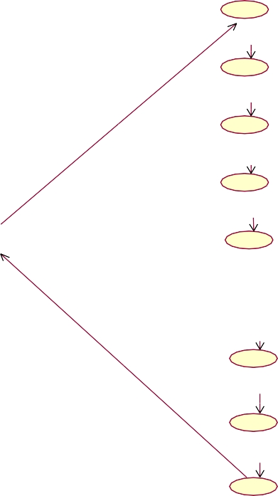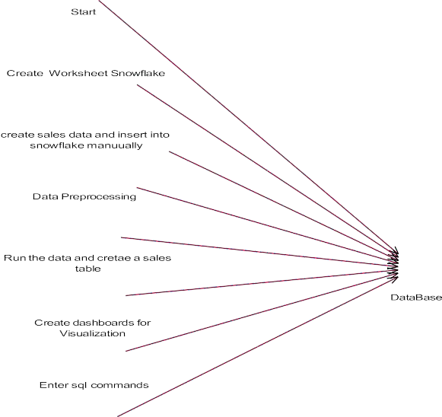

End

### EXPLANATION:

Use-case diagrams describe the high-level functions and scope of a system. These diagrams also identify the interactions between the system and its actors. The use cases and actors in use-case diagrams describe what the system does and how the actors use it, but not how the system operates internally.

* + 1. **Class Diagram**

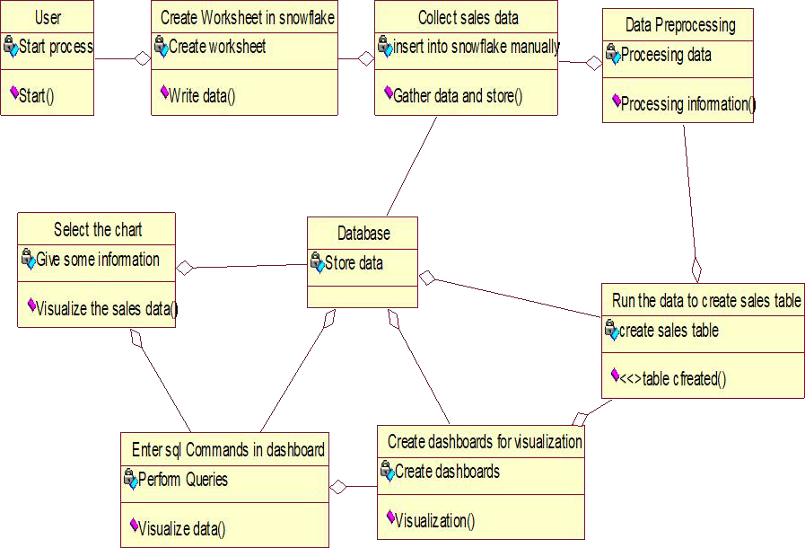

### EXPLANATION

In this class diagram in software engineering, a class diagram in the Unified Modeling Language (UML) is a type of static structure diagram that describes the structure of a system by showing the system's classes, their attributes, operations (or methods), and the relationships among objects.

* + 1. **Object Diagram**

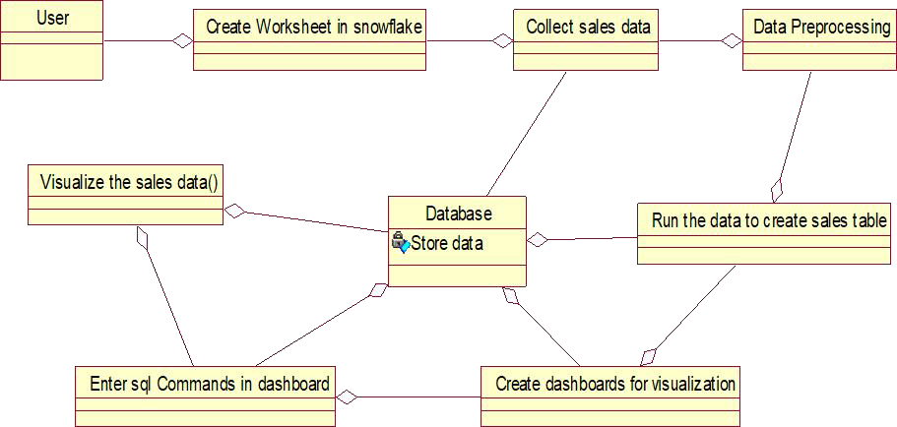

### EXPLANATION:

Object is an instance of a class in a particular moment in runtime that can have its own state and data values. Likewise, a static UML object diagram is an instance of a class diagram; it shows a snapshot of the detailed state of a system at a point in time, thus an object diagram encompasses objects and their relationships which may be considered a special case of a class diagram or a communication diagram.

### STATE DIAGRAM:



|  |  |  |
| --- | --- | --- |
| Select Chart |  | Visualize the sales |
|  |

**EXPLANATION:**



These terms are often used interchangeably. So simply, a state diagram is used to model the dynamic behavior of a class in response to time and changing external stimuli. We can say that each and every class has a state but we don’t model every class using State diagrams. We prefer to model the states with three or more states.

* + 1. **Sequence Diagram:**

User

Snowflake

Create Worksheet

Collect Sales

Data

|  |  |  |
| --- | --- | --- |
| Data  Preprocessing |  | Run the data and |
| create sales table |

Create

dashboards

|  |  |  |  |  |
| --- | --- | --- | --- | --- |
| Enter SQL  Commands |  | Visualize sales |  | Database |
| data |

Start

Create

Create sales table

Data processing

Create dashboards

Enter SQL Commands

Select chart

Visualize data

Visualizing data

### EXPLANATION:

A sequence diagram in Unified Modeling Language (UML) is a kind of interaction diagram that shows how processes operate with one another and in what order. It is a construct of a Message Sequence Chart. A sequence diagram shows object interactions arranged in time sequence. It depicts the objects and classes involved in the scenario and the sequence of messages exchanged between the objects needed to carry out the functionality of the scenario.

* + 1. **Collaboration Diagram:**

1: Start 2: Create worksheet

3: Create sales table

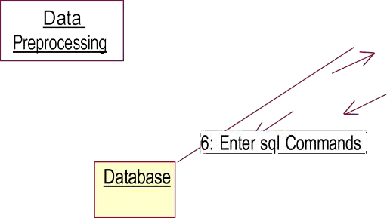

4: Data processing

9: Visualizing data

### EXPLANATION:

A collaboration diagram, also called a communication diagram or interaction diagram, is an illustration of the relationships and interactions among software objects in the Unified Modeling Language (UML). The concept is more than a decade old although it has been refined as modeling paradigms have evolved.

* + 1. **Activity Diagram:**



Start

Create worksheet Snowflake

Collect the sales data and insert into snowflake

Data Preprocessing

Run the data create table

Visualize the

Enter dashboards

Enter SQL

select chart

### EXPLANATION:

Activity diagrams are graphical representations of workflows of stepwise activities and actions with support for choice, iteration and concurrency. In the Unified Modeling Language, activity diagrams can be used to describe the business and operational step-by-step workflows of components in a system. An activity diagram shows the overall flow of control.

* + 1. **Component Diagram:**

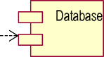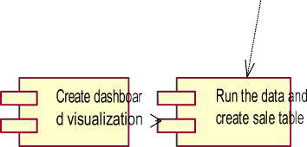

### EXPLANATION:

In the Unified Modeling Language, a component diagram depicts how components are wired together to form larger components and or software systems. They are used to illustrate the structure of arbitrarily complex systems. User gives main query and it converted into sub queries and sends through data dissemination to data aggregators. Results are to be showed to user by data aggregators. All boxes are components and arrow indicates dependencies.

* + 1. **E-R Diagram:**

Create dashboards for visualization

Enter SQL commands in dashboard to visualize

Run the data to create sales table

Select chart



Visualize the sales data

User

Details

Verify Data base

Create Worksheet in Snowflake

Data preprocessing

Collect Sales data and insert into snowflake manually

### EXPLANATION:

Entity-Relationship Model (ERM) is an abstract and conceptual representation of data. Entity- relationship modeling is a database modeling method, used to produce a type of conceptual schema or semantic data model of a system, often a relational database.

* + 1. **Data Flow Diagram:**



Start

Create a Worksheet in snowflake

Collect sales data and insert into snowflake manually

Data preprocessing

Data preprocessing

Run the data to create sales table

Create dashboards for visualizations

Enter SQL commands in dashboard to visualize

Select chart and visualize sale data

Data base

End

### EXPLANATION:

The refined representation of a process can be done in another data-flow diagram, which subdivides this process into sub-processes. The data-flow diagram is a tool that is part of structured analysis and data modeling. When using UML, the activity diagram typically takes over the role of the data-flow diagram.

* + 1. **Deployment Diagram:**

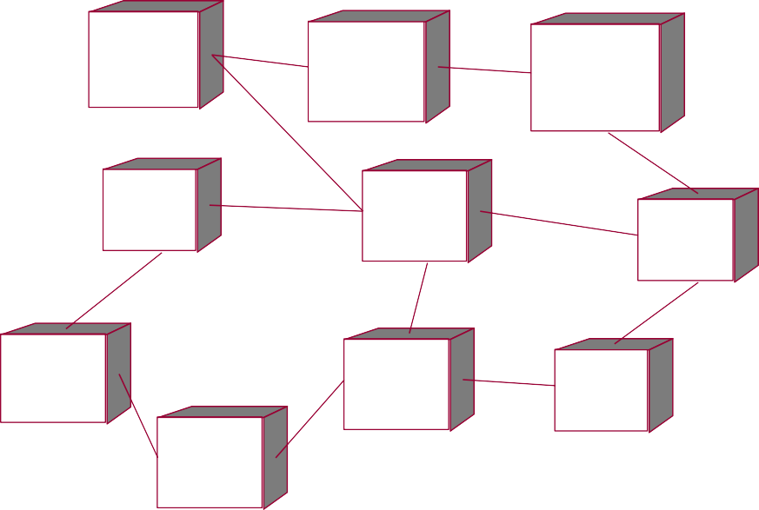

User

Create Work Sheet Snowflake

Collect Sales data and insert into

Visualize the data

Database

Data-Preprocessing

Select the chart'

Create dashboards for

Run the data and create

Enter SQL commands in

### EXPLANATION:

In the Unified Modeling Language, a component diagram depicts how components are wired together to form larger deployment and or software systems. They are used to illustrate the structure of arbitrarily complex systems. User gives main query and it converted into sub queries and sends through data dissemination. Results are to be showed to user by data aggregators. All boxes are arrow indicates dependencies.

* 1. **System Architecture**

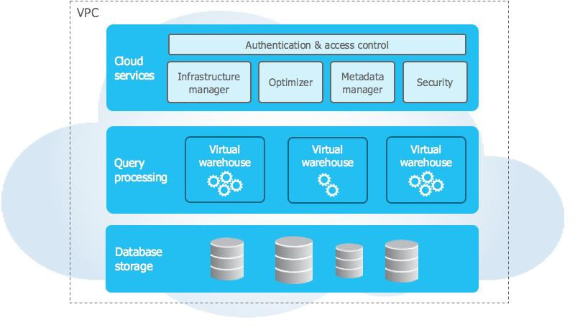

**System Architecture Model**

# CHAPTER 5 IMPLEMENTATION

### TECHNOLOGIES USED:

* + 1. **SNOWFLAKE:**

Snowflake is a modern, cloud-native data platform designed to handle a wide range of data processing, analytics, and storage needs. Unlike traditional data warehouses, Snowflake leverages advanced technologies to provide unmatched scalability, flexibility, and performance. At its core, Snowflake integrates cutting-edge features such as columnar storage, real-time query optimization, and support for semi-structured data formats like JSON and Parquet. It also offers serverless capabilities, seamless scalability, and robust security measures. By combining these technologies with an intuitive interface and wide integration capabilities, Snowflake empowers businesses to harness the full potential of their data, driving informed decision-making and innovation.

**Importance of Snowflake:**

Snowflake has become a crucial platform in the data ecosystem due to its innovative architecture and ability to address modern data management challenges. Its importance lies in its ability to empower businesses to efficiently store, manage, and analyze large volumes of structured and semi-structured data.

Snowflake is a revolutionary cloud-based data platform that has redefined how organizations store, manage, and analyze data. Snowflake supports structured and semi structured data formats like JSON, Parquet, and Avro, enabling organizations to handle diverse data types with ease. Security is a core feature of Snowflake, offering encryption, role-based access controls, and compliance with industry standards like GDPR, HIPAA, and SOC. This ensures data integrity and protects sensitive information. Its significance lies in its ability to address the limitations of traditional data warehouses and adapt to the growing demands of modern data-driven enterprises Coud-Native and Scalable. Snowflake is built entirely for the cloud, allowing businesses to scale their resources dynamically. Whether dealing with massive datasets or fluctuating workloads, Snowflake provides seamless elasticity, enabling organizations to optimize performance and costs.

**Features of Snowflake:**

Snowflake’s features make it a powerful, user-friendly solution for modern data needs. Snowflake simplifies data management, reduces costs with a pay-as-you-go model, and enables businesses to make data-driven decisions through advanced analytics. It integrates with major data tools and ensures robust security, making it essential modern enterprises.

* + - 1. Cloud-Native Architecture: Built specifically for public clouds like AWS, Azure, and Google Cloud.
      2. Separation of Compute and Storage: Enables independent scaling for cost efficiency and performance.
      3. Support for Semi-Structured Data: Handles formats like JSON and Parquet seamlessly.
      4. Data Sharing: Facilitates secure, real-time sharing of data without duplication.
      5. Scalability and Performance: Supports high-concurrency workloads with fast query execution.

### CODE:

CREATE DATABASE HealthAnalytics; CREATE SCHEMA DataStructure; CREATE TABLE patient_demographics (

patient_id INT,

first_name VARCHAR(50), last_name VARCHAR(50), birth_date DATE,

gender VARCHAR(10), address VARCHAR(100), city VARCHAR(50), state VARCHAR(20),

zip_code VARCHAR(10)

);

CREATE TABLE clinical_data ( patient_id INT, encounter_date DATE,

diagnosis_code VARCHAR(20), procedure_code VARCHAR(20), medication_code VARCHAR(20), physician_id INT

);

INSERT INTO patient_demographics (patient_id, first_name, last_name, birth_date, gender, address, city, state, zip_code)

VALUES

(1, 'John', 'Doe', '1980-05-25', 'Male', '123 Main St', 'Anytown', 'NY', '12345'),

(2, 'Jane', 'Smith', '1975-08-12', 'Female', '456 Elm St', 'Anycity', 'CA', '67890'),

(3, 'Michael', 'Johnson', '1990-03-15', 'Male', '789 Maple Ave', 'Anothercity', 'TX', '56789'),

(4, 'Emily', 'Brown', '1985-11-20', 'Female', '321 Oak St', 'Yetanothercity', 'FL', '98765'),

(5, 'Liam', 'White', '1982-07-14', 'Male', '400 Oak St', 'Smalltown', 'OR', '12312'),

(6, 'Emma', 'Green', '1991-04-22', 'Female', '421 Palm St', 'Lakecity', 'TX', '45454'),

(7, 'Noah', 'Black', '1984-01-02', 'Male', '786 Pine Ave', 'Hilltown', 'IL', '65478'),

(8, 'Ava', 'Davis', '1992-09-17', 'Female', '122 Spruce Dr', 'Seaside', 'NY', '21345'),

(9, 'James', 'Moore', '1980-03-09', 'Male', '967 Birch St', 'Rivercity', 'LA', '98321'),

(10, 'Mia', 'Taylor', '1993-12-04', 'Female', '342 Elm Dr', 'Forestville', 'CO', '85732'),

(11, 'Elijah', 'Anderson', '1977-11-30', 'Male', '557 Cedar Ave', 'Metrocity', 'CA', '93456'),

(12, 'Isabella', 'Thomas', '1990-05-13', 'Female', '765 Oak Blvd', 'Villagetown', 'FL', '76345'),

(13, 'Lucas', 'Jackson', '1986-02-21', 'Male', '983 Maple Dr', 'Parkcity', 'WI', '54321'),

(14, 'Charlotte', 'Harris', '1983-06-28', 'Female', '200 Willow Ln', 'Brooktown', 'MO', '67543'),

(15, 'Benjamin', 'Lee', '1987-07-11', 'Male', '101 Maple St', 'Greenville', 'NV', '34678'),

(16, 'Amelia', 'King', '1995-03-08', 'Female', '421 Oak St', 'Sunnytown', 'MT', '45873'),

(17, 'Oliver', 'Hill', '1976-04-26', 'Male', '823 Pine St', 'Cloudcity', 'AL', '65423'),

(18, 'Sophia', 'Scott', '1991-11-07', 'Female', '756 Birch Ave', 'Raintown', 'GA', '31245'),

(19, 'Ethan', 'Adams', '1988-02-14', 'Male', '234 Maple Blvd', 'Snowcity', 'TN', '76543'),

(20, 'Mason', 'Baker', '1985-10-19', 'Male', '543 Oak Ln', 'Wheatville', 'OK', '67543'),

(21, 'Harper', 'Gonzalez', '1993-01-03', 'Female', '233 Cedar St', 'Valleytown', 'AZ', '67521'),

(22, 'Alexander', 'Young', '1990-06-22', 'Male', '782 Pine St', 'Riverstone', 'AR', '54323'),

(23, 'Aiden', 'Mitchell', '1994-05-18', 'Male', '654 Birch Blvd', 'Mountaincity', 'KY', '23456'),

(24, 'Scarlett', 'Perez', '1981-07-31', 'Female', '111 Elm St', 'Sunsettown', 'SC', '56789'),

(25, 'Logan', 'Hall', '1979-12-12', 'Male', '333 Cedar Dr', 'Brighttown', 'IA', '54312'); INSERT INTO clinical_data (patient_id, encounter_date, diagnosis_code, procedure_code, medication_code, physician_id)

VALUES

(1, '2023-01-01', 'D123', 'P456', 'M001', 101),

(2, '2023-01-02', 'D234', 'P567', 'M002', 102),

(3, '2023-01-03', 'D345', 'P678', 'M003', 103),

(4, '2023-01-04', 'D456', 'P789', 'M004', 104),

(5, '2023-01-05', 'D567', 'P890', 'M005', 105),

(6, '2023-01-06', 'D678', 'P901', 'M006', 106),

(7, '2023-01-07', 'D789', 'P012', 'M007', 107),

(8, '2023-01-08', 'D890', 'P123', 'M008', 108),

(9, '2023-01-09', 'D901', 'P234', 'M009', 109),

(10, '2023-01-10', 'D012', 'P345', 'M010', 110),

(11, '2023-01-11', 'D123', 'P456', 'M011', 111),

(12, '2023-01-12', 'D234', 'P567', 'M012', 112),

(13, '2023-01-13', 'D345', 'P678', 'M013', 113),

(14, '2023-01-14', 'D456', 'P789', 'M014', 114),

(15, '2023-01-15', 'D567', 'P890', 'M015', 115),

(16, '2023-01-16', 'D678', 'P901', 'M016', 116),

(17, '2023-01-17', 'D789', 'P012', 'M017', 117),

(18, '2023-01-18', 'D890', 'P123', 'M018', 118),

(19, '2023-01-19', 'D901', 'P234', 'M019', 119),

(20, '2023-01-20', 'D012', 'P345', 'M020', 120),

(21, '2023-01-21', 'D123', 'P456', 'M021', 121),

(22, '2023-01-22', 'D234', 'P567', 'M022', 122),

(23, '2023-01-23', 'D345', 'P678', 'M023', 123),

(24, '2023-01-24', 'D456', 'P789', 'M024', 124),

(25, '2023-01-25', 'D567', 'P890', 'M025', 125);

SELECT AVG(DATEDIFF(YEAR, birth_date, CURRENT_DATE())) AS avg_patient_age FROM patient_demographics;

SELECT

gender,

AVG(DATEDIFF(YEAR, birth_date, CURRENT_DATE())) AS avg_age FROM

patient_demographics GROUP BY

gender; SELECT

diagnosis_code,

COUNT(*) AS encounter_count FROM

clinical_data GROUP BY

diagnosis_code ORDER BY

encounter_count DESC; SELECT

pd.patient_id, pd.first_name, pd.last_name, pd.gender, pd.birth_date, cd.encounter_date, cd.diagnosis_code, cd.procedure_code,

cd.medication_code FROM

patient_demographics pd JOIN

clinical_data cd ON pd.patient_id = cd.patient_id ORDER BY

pd.patient_id, cd.encounter_date; WITH patient_encounter_stats AS (

SELECT

pd.patient_id, pd.first_name, pd.last_name, pd.gender,

COUNT(*) AS total_encounters, MAX(cd.encounter_date) AS latest_encounter_date, MIN(cd.encounter_date) AS earliest_encounter_date,

AVG(DATEDIFF('day', cd.encounter_date, CURRENT_DATE())) AS avg_days_since_last_encounter

FROM

patient_demographics pd JOIN

clinical_data cd ON pd.patient_id = cd.patient_id GROUP BY

pd.patient_id, pd.first_name, pd.last_name, pd.gender

) SELECT

patient_id, first_name, last_name, gender, total_encounters,

earliest_encounter_date, latest_encounter_date, avg_days_since_last_encounter

FROM

patient_encounter_stats ORDER BY

total_encounters DESC;

* 1. **Output:**

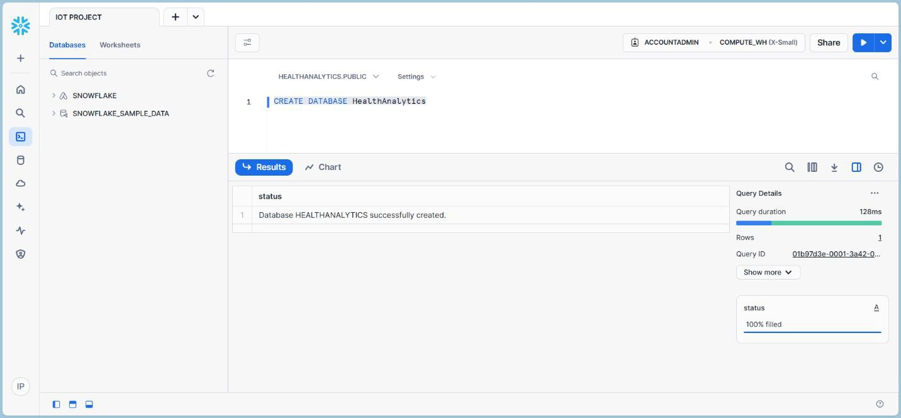

Figure 5.3.1: Database Creation

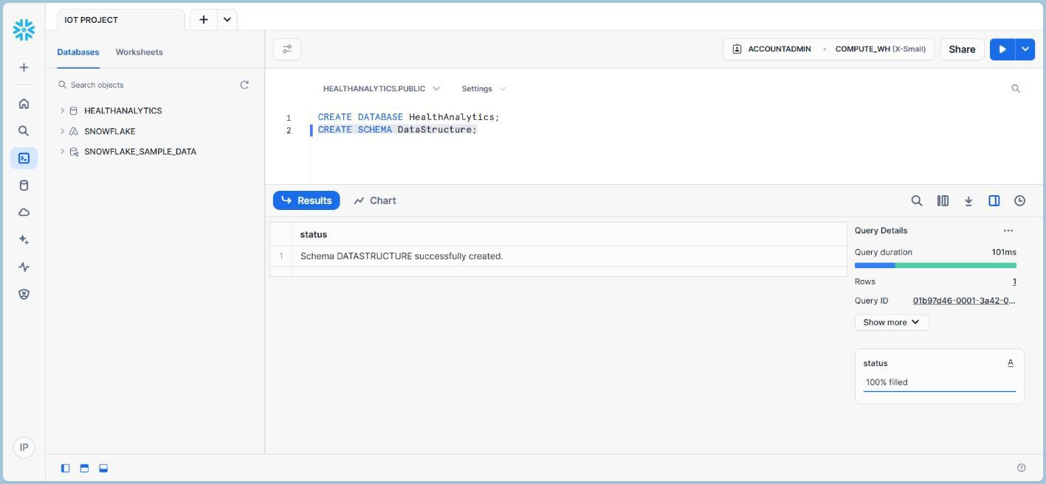

Figure 5.3.2: Schema Creation

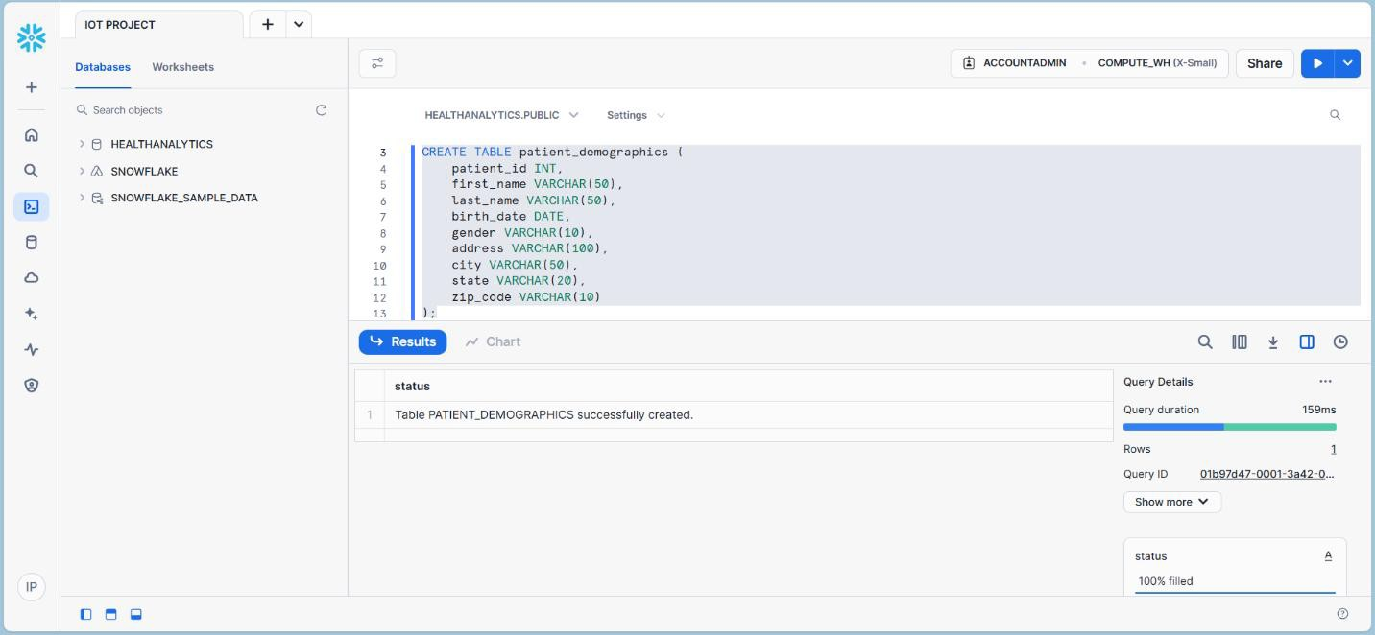

Figure 5.3.3: The Patient Demographics table is enriched with essential details such as patient IDs, names, birth dates, genders, and addresses, forming a crucial foundation for linking demographics with clinical insights.

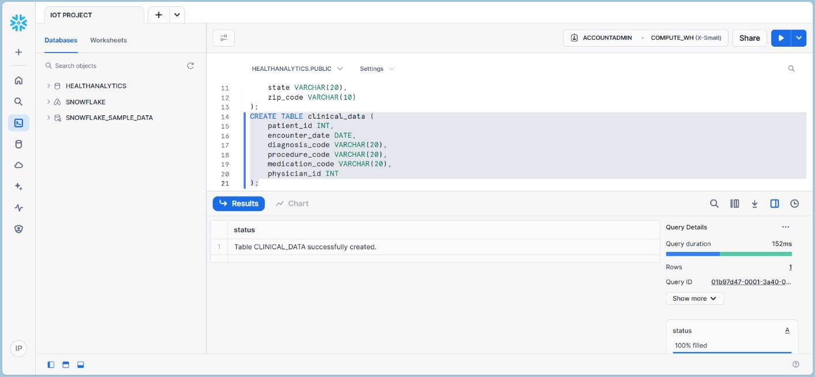

Figure 5.3.4: The Clinical Data table has been populated with key details of patient encounters, including diagnosis codes, procedure codes, medications, and physician IDs. This dataset is vital for analyzing clinical patterns and understanding patient care journeys.

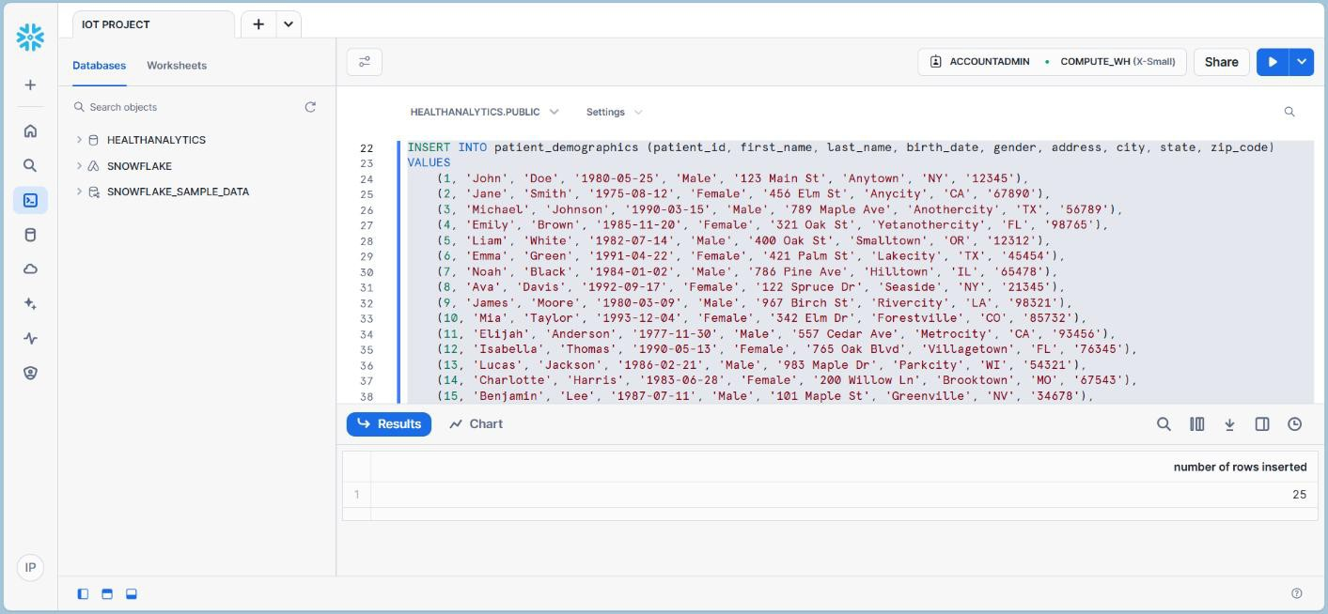

Figure 5.3.5: The insertion into the Patient Demographics table includes essential patient information such as IDs, names, birth dates, genders, and addresses, establishing a crucial link for further clinical analysis.

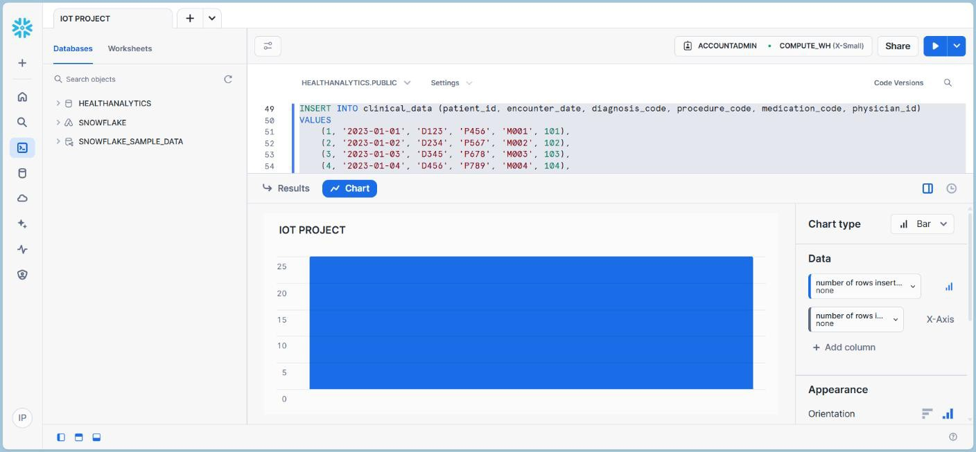

Figure 5.3.6: The insertion into the Clinical Data table includes important encounter details such as diagnosis codes, procedure codes, medication prescriptions, and physician IDs, enabling the analysis of clinical patterns and patient care outcomes.

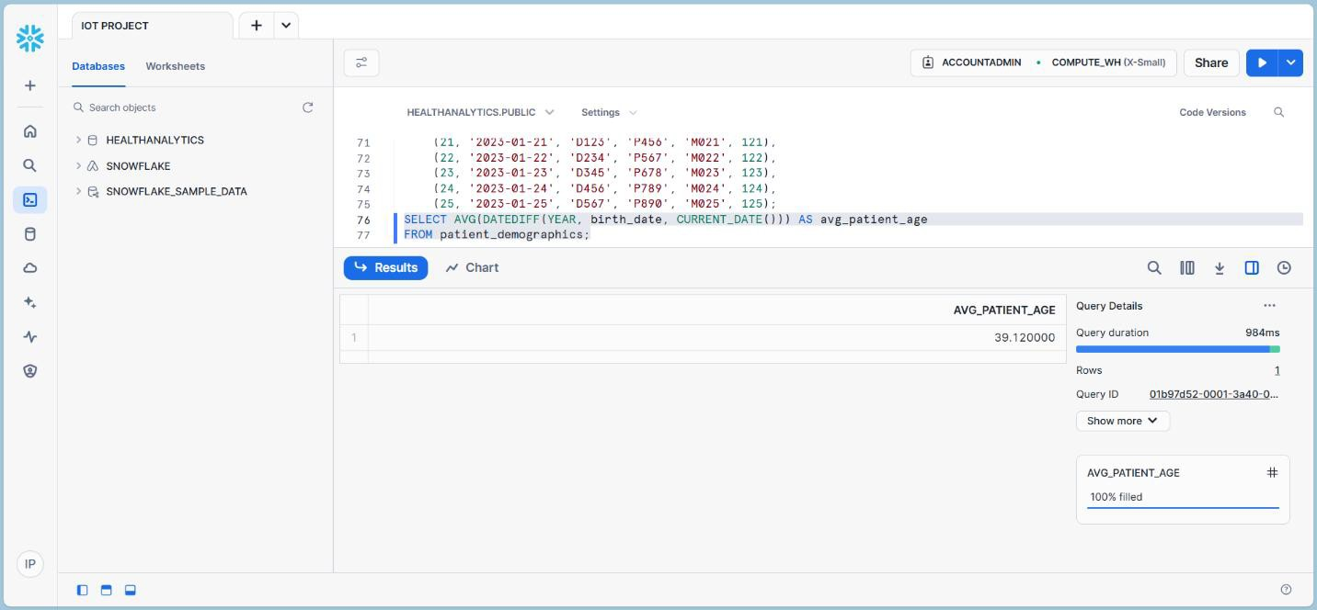

Figure 5.3.7: Calculates the overall average age of patients, offering a snapshot of the patient population's age distribution.

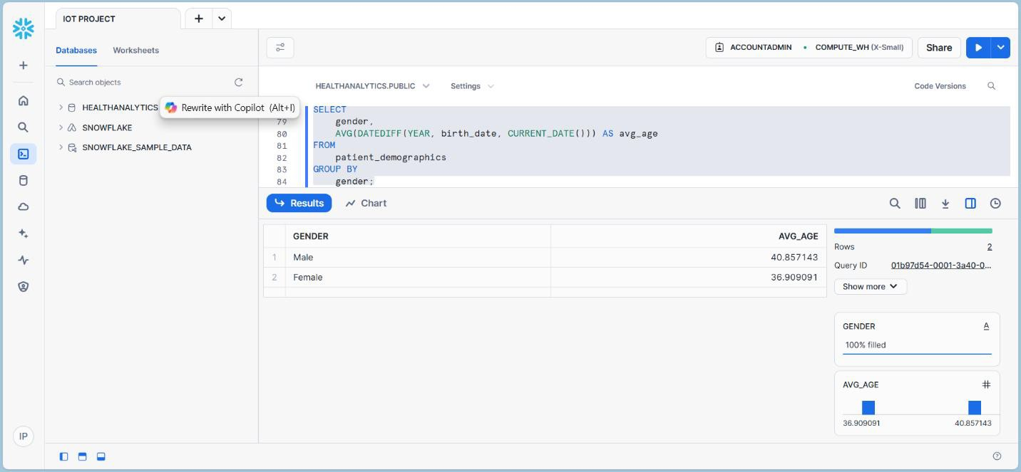

Figure 5.3.8: Provides a breakdown of the average patient age by gender, revealing age- related trends across male and female patients.

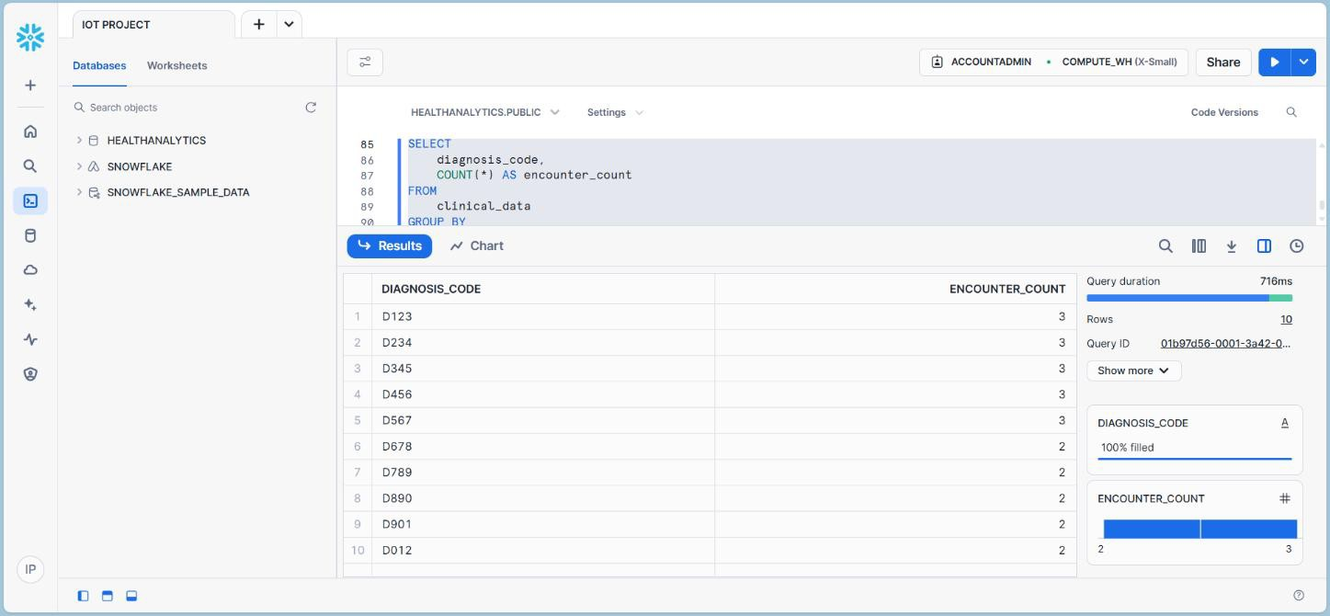

Figure 5.3.9: Tallies the number of patient encounters for each diagnosis code, highlighting the most frequently observed medical conditions.

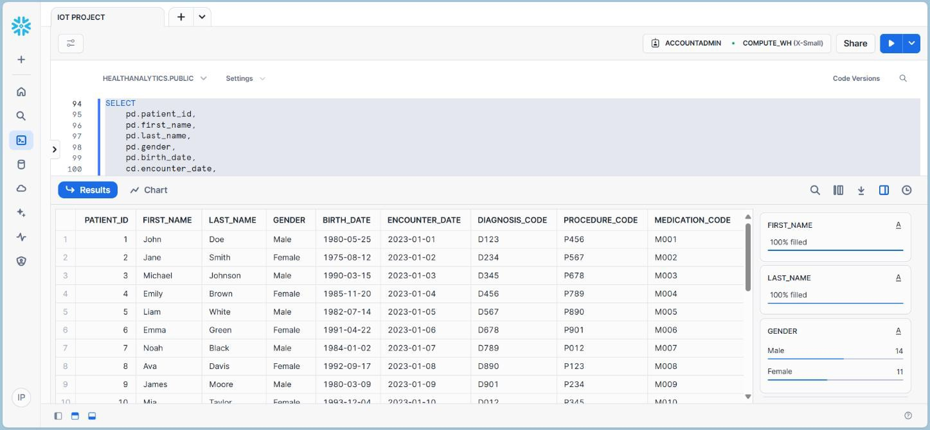

Figure 5.3.10: Combines patient demographic details with their clinical encounters, allowing a deeper understanding of health trends across various patient profiles.

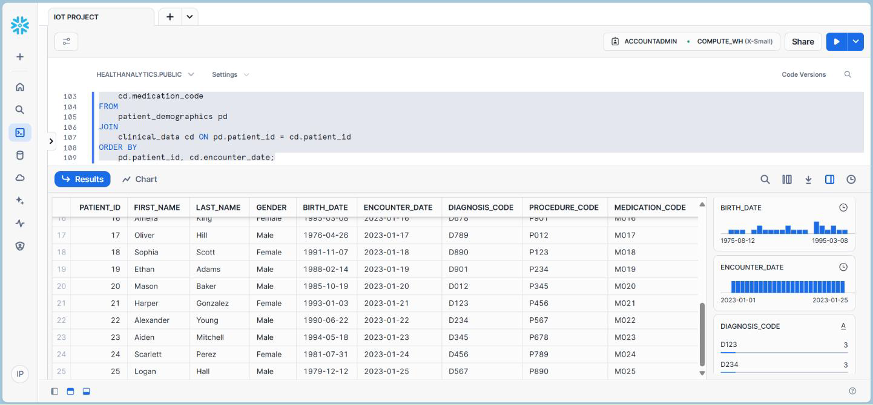

Figure 5.3.11: Delivers an overview of key encounter statistics for each patient, such as total visits and the time elapsed since the last visit.

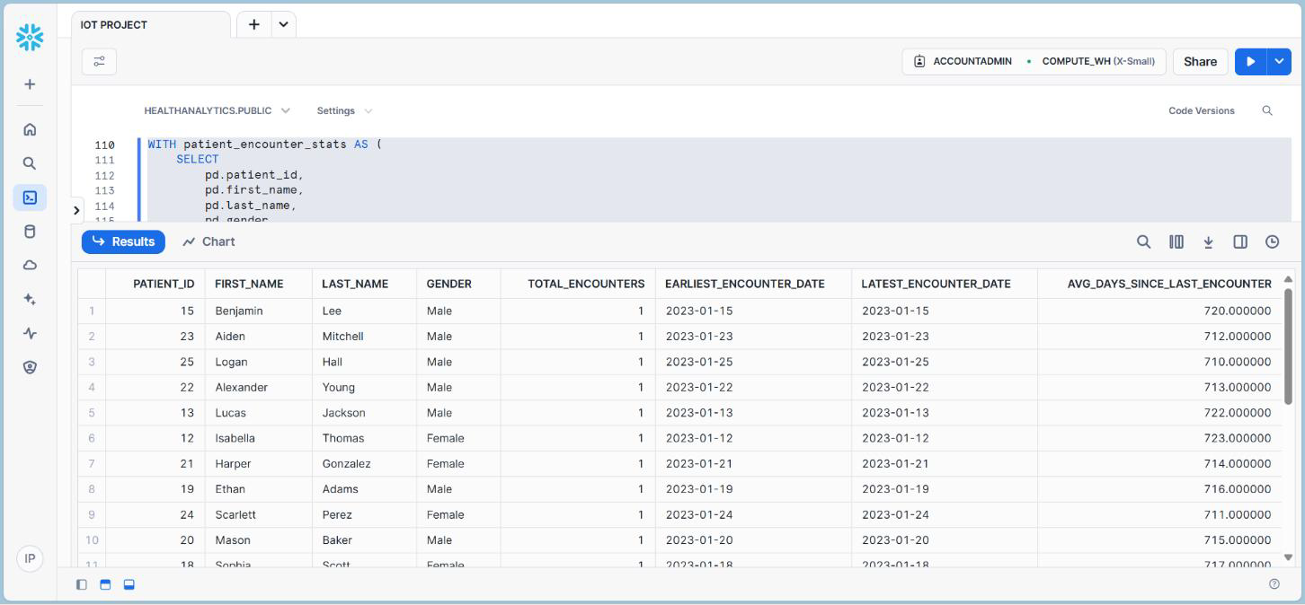

Figure 5.3.12: Uses a common table expression (CTE) to track patient encounters over time, summarizing key stats like first and last visit dates.

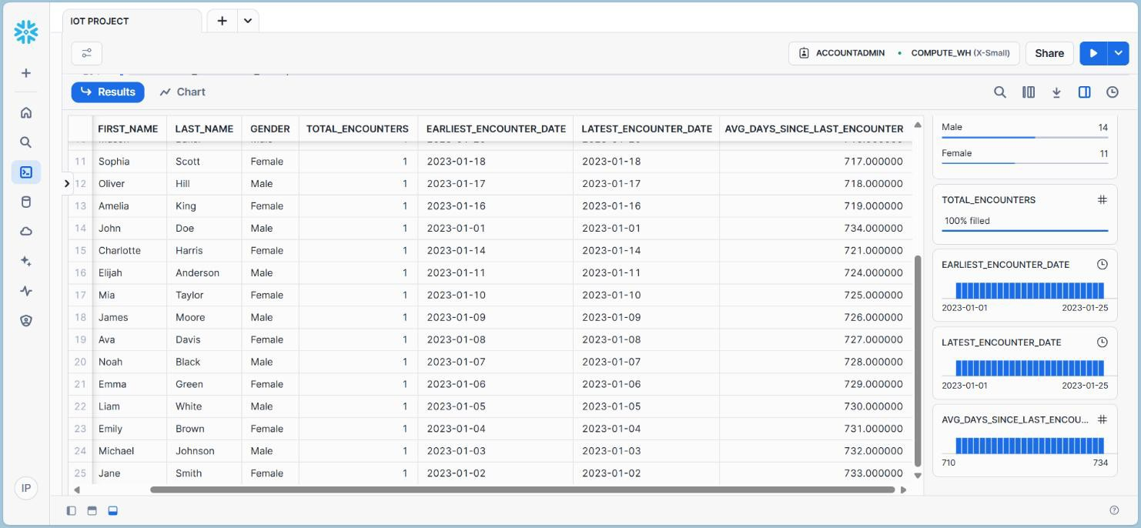

Figure 5.3.13: Analyzes patient engagement with healthcare services by evaluating their encounter history and identifying patterns in healthcare utilization.

# CHAPTER 6 SOFTWARE TESTING

### GENERAL

The purpose of testing is to discover errors. Testing is the process of trying to discover every conceivable fault or weakness in a work product. It provides a way to check the functionality of components, sub-assemblies, assemblies and/or a finished product It is the process of exercising software with the intent of ensuring that the Software system meets its requirements and user expectations and does not fail in an unacceptable manner. There are various types of tests. Each test type addresses a specific testing requirement.

### DEVELOPING METHODOLOGIES

The test process is initiated by developing a comprehensive plan to test the general functionality and special features on a variety of platform combinations. Strict quality control procedures are used. The process verifies that the application meets the requirements specified in the system requirements document and is bug free. The following are the considerations used to develop the framework from developing the testing methodologies.

**Types of Tests:**

##### Unit Testing:

Unit testing involves the design of test cases that validate that the internal program logic is functioning properly, and that program input produce valid outputs. All decision branches and internal code flow should be validated. It is the testing of individual software units of the application .it is done after the completion of an individual unit before integration. This is a structural testing, that relies on knowledge of its construction and is invasive. Unit tests perform basic tests at component level and test a specific business process, application, and/or system configuration. Unit tests ensure that each unique path of a business process performs accurately to the documented specifications and contains clearly defined inputs and expected results.

##### Functional Test:

Functional tests provide systematic demonstrations that functions tested are available as specified by the business and technical requirements, system documentation, and user manuals. Functional testing is centered on the following items:

Valid Input : identified classes of valid input must be accepted. Invalid Input : identified classes of invalid input must be rejected. Functions : identified functions must be exercised.

Output : identified classes of application outputs must be exercised. Systems/Procedures : interfacing systems or procedures must be invoked.

##### System Test:

System testing ensures that the entire integrated software system meets requirements. It tests a configuration to ensure known and predictable results. An example of system testing is the configuration-oriented system integration test. System testing is based on process descriptions and flows, emphasizing pre-driven process links and integration points.

##### Performance Test:

The Performance test ensures that the output be produced within the time limits, and the time taken by the system for compiling, giving response to the users and request being send to the system for to retrieve the results.

##### Integration Testing:

Software integration testing is the incremental integration testing of two or more integrated software components on a single platform to produce failures caused by interface defects.

The task of the integration test is to check that components or software applications, e.g. components in a software system or – one step up – software applications at the company level – interact without error.

# CHAPTER 7 CONCLUSION

### CONCLUSION:

The Snowflake platform transforms healthcare analytics by offering a centralized, secure, and scalable solution for managing clinical and operational data. It overcomes challenges like data silos and integration inefficiencies by consolidating fragmented datasets into a unified repository. With real-time processing and advanced analytics, Snowflake enables predictive modeling, resource optimization, and evidence-based decision-making to improve patient outcomes. Its compliance with HIPAA and GDPR ensures secure handling of sensitive data. By supporting applications in drug discovery and supply chain management, Snowflake empowers healthcare organizations to deliver efficient, high-quality, and cost-effective care.

### FUTURE ENHANCEMENTS:

The following aspects deserve more attention and research in the future:

##### Integration with Machine Learning and AI:

Integrate Snowflake with AI and machine learning tools for predictive analytics, automated decision-making, and personalized treatment recommendations.

##### Enhanced Data Security and Privacy:

Develop advanced encryption and access controls to ensure stronger protection of sensitive healthcare data and compliance with privacy regulations.

##### Real-Time Predictive Analytics:

Improve real-time data ingestion and processing to enable timely, predictive insights, enhancing decision-making in critical healthcare scenarios.

#### 7.3 REFERENCES:

1. S. Rodriguez, L. Carter, and F. Wilson, "Overcoming data silos in healthcare using Snowflake’s data-sharing capabilities," *J. Data Sci. Anal.*, vol. 9, no. 2, pp. 67–78, 2020.
2. L. Smith, T. Green, and P. Adams, "Applications of Snowflake in healthcare: A case study on predictive analytics," in *Proc. IEEE Big Data Conf.*, pp. 234–240, 2020.
3. G. Lee, M. Green, and A. Carter, "Snowflake and its impact on operational efficiency in healthcare data management," *J. Healthcare Syst. Manag.*, vol. 22, no. 1, pp. 45–55, 2020.
4. T. Brown, E. Clark, and R. Davis, "Integrating electronic health records with Snowflake for real-time insights," *Healthcare Inform. Res.*, vol. 18, no. 3, pp. 134–145, 2021.
5. P. Nguyen and M. Lee, "Securing healthcare data with Snowflake's cloud architecture," *IEEE Trans. Cloud Comput.*, vol. 10, no. 2, pp. 250–259, 2022.
6. H. Green, J. Black, and M. White, "Machine learning with Snowflake: Implications for healthcare analytics," in *ACM Digital Health Proc.*, pp. 112–120, 2022.
7. B. Johnson and M. Patel, "Leveraging Snowflake for integrated healthcare decision-making systems," *J. Cloud-Based Healthcare Solutions*, vol. 14, no. 1, pp. 56–67, 2022.
8. E. Wilson, S. Thompson, and J. Clark, "Snowflake’s cloud architecture: A secure solution for healthcare data management," *Int. J. Healthcare Cloud Comput.*, vol. 13, no. 3, pp. 102–113, 2021.
9. V. Kumar and A. Shukla, "Big data solutions for healthcare: Leveraging Snowflake for operational efficiency," *J. Med. Inform. Decis. Mak.*, vol. 11, no. 4, pp. 78–89, 2021.
10. R. Patel and K. Johnson, "Transforming healthcare data management using Snowflake," *J. Cloud Comput. Res.*, vol. 12, no. 1, pp. 12–22, 2021.
11. C. Davis and T. Lee, "Data interoperability in healthcare: Snowflake’s role in seamless data exchange," in *Proc. Int. Conf. Health Inform.*, pp. 123–131, 2021.
12. J. Wright and D. Harris, "Reducing healthcare costs with Snowflake’s efficient data storage solutions," *J. Healthcare Econ. Anal.*, vol. 14, no. 2, pp. 76–88, 2021.
13. J. Chen, R. White, and L. Patel, "Cloud-based platforms in healthcare analytics: Integrating patient data with Snowflake," *Int. J. Healthcare Inf. Syst. Inform.*, vol. 15, no. 3, pp. 45–58, 2022.
14. H. Thomas and N. Taylor, "Enhancing predictive healthcare analytics with Snowflake’s real- time processing," *J. Healthcare Data Sci.*, vol. 21, no. 3, pp. 112–123, 2023.
15. F. Adams and P. Wright, "Integrating Snowflake with healthcare AI for smarter patient care,"

*J. AI Health.*, vol. 19, no. 2, pp. 88–98, 2022.

1. L. Mitchell and S. Phillips, "Real-time patient care analytics with Snowflake: A case study," *J. Health Technol.*, vol. 15, no. 3, pp. 201–212, 2022.
2. P. Nguyen and M. Lee, "Securing healthcare data with Snowflake's cloud architecture," *IEEE Trans. Cloud Comput.*, vol. 10, no. 2, pp. 250–259, 2022.
3. M. Jackson and P. Lee, "The future of healthcare analytics: Snowflake and AI-powered solutions," *J. Data Anal. Med.*, vol. 20, no. 2, pp. 45–56, 2023.
4. A. Smith and R. Kumar, "Optimizing healthcare analytics with Snowflake for better patient outcomes," *J. Health Inf. Sci.*, vol. 16, no. 2, pp. 98–109, 2023.
5. K. Carter and L. Edwards, "Improving healthcare decision-making using Snowflake’s data warehouse features," *Int. J. Healthcare Decis.-Making*, vol. 23, no. 1, pp. 98–109, 2023.
6. S. Rodriguez, L. Carter, and F. Wilson, "Overcoming data silos in healthcare using Snowflake’s data-sharing capabilities," *J. Data Sci. Anal.*, vol. 9, no. 2, pp. 67–78, 2020.